

Bansilal Ramnath Agarwal Charitable Trust’s

# Vishwakarma Institute of Information Technology

Business Intelligence and Data Analytics

(Assignments 6)

|  |  |  |  |
| --- | --- | --- | --- |
| Name | Roll No. | GR No. | Batch |
| Chetan Chinchulkar | 324017 | 21810350 | E9 (Comp D) |
| Nikit Gokhe | 324022 | 21810522 | E9 (Comp D) |
| Sahil Langha | 324032 | 21810533 | E9 (Comp D) |
| Kunal Parkhe | 324040 | 21810049 | E9 (Comp D) |

GROUP MEMBERS:

# Assignment No. 06

# Aim:

Integrate **Tableau** with google sheet and analyze output in **Tableau** Dashboard.

# Objective: To make dashboard using google sheets

# Data Description:

The data is year-wise batting stats of Sachin Tendulkar from the year 2002 to 2013, which include year-wise runs, average, dot balls percentage, runs, Highest Score, no of 100s/50s etc.

# Theory:

A dashboard is a collection of several views, letting you compare a variety of data simultaneously. For example, if you have a set of views that you review every day, you can create a dashboard that displays all the views at once, rather than navigate to separate worksheets.

Like worksheets, you access dashboards from tabs at the bottom of a workbook. Data in sheets and dashboards is connected; when you modify a sheet, any dashboards containing it change, and vice versa. Both sheets and dashboards update with the latest available data from the data source.

# Website Used: <http://www.cricmetric.com/playerstats.py?player=SR%20Tendulkar&role=batsman>

# Input:

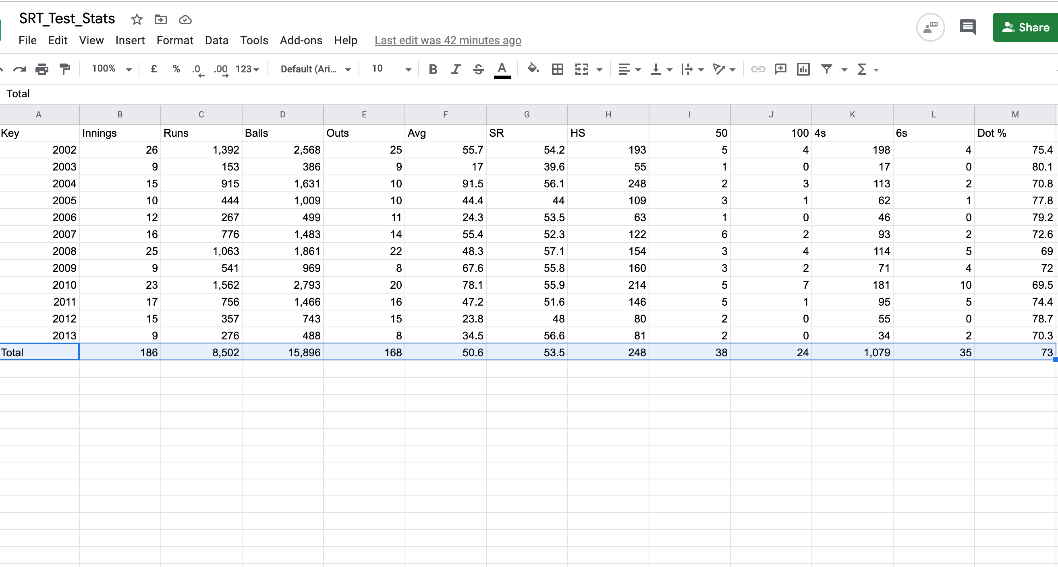**Name**: SRT_Test_Stats

# Output:

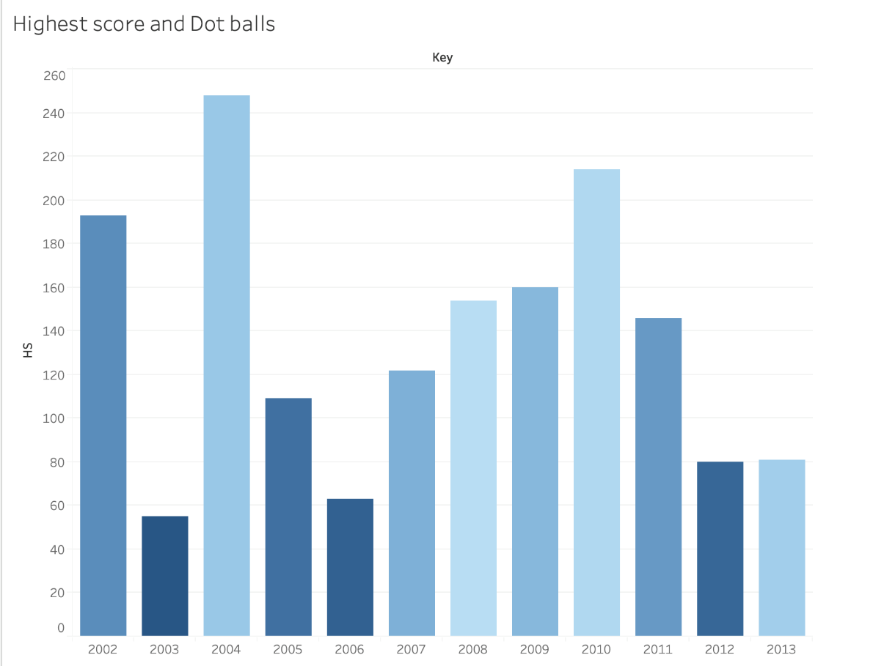

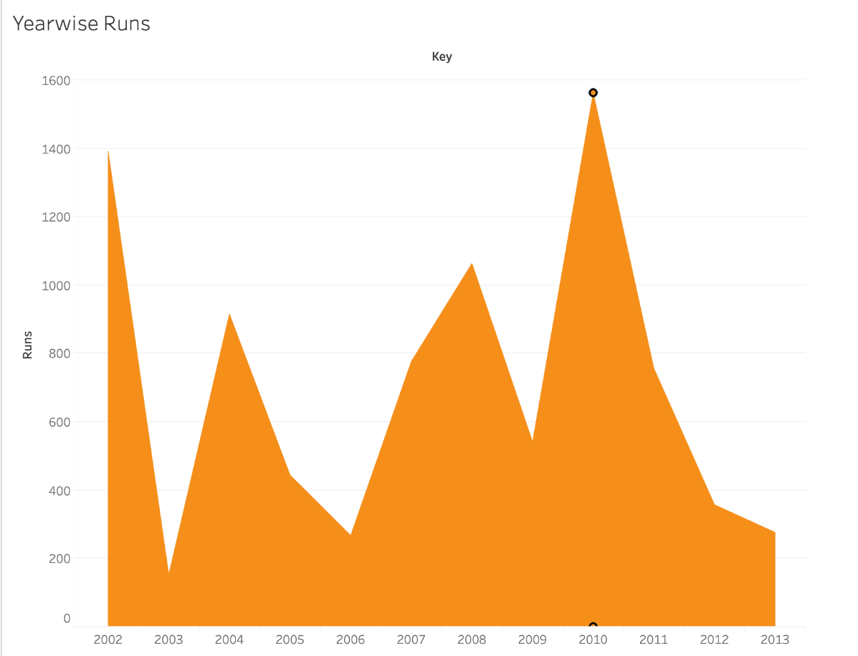

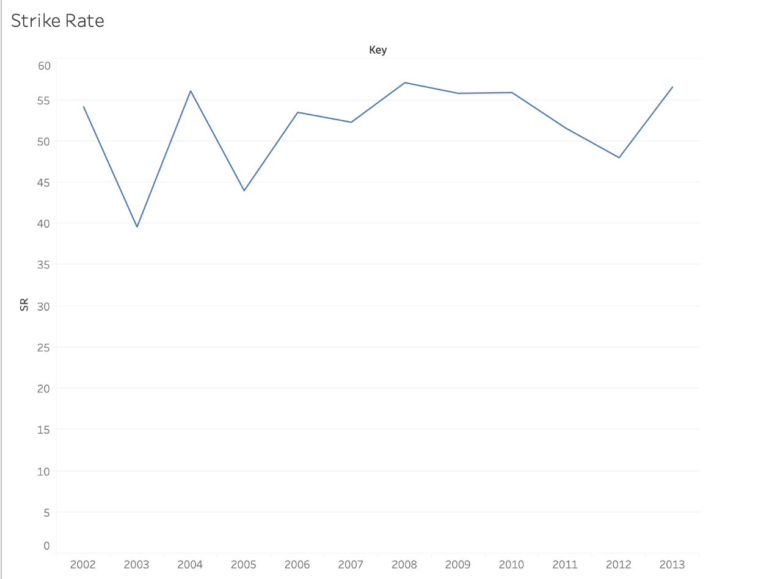

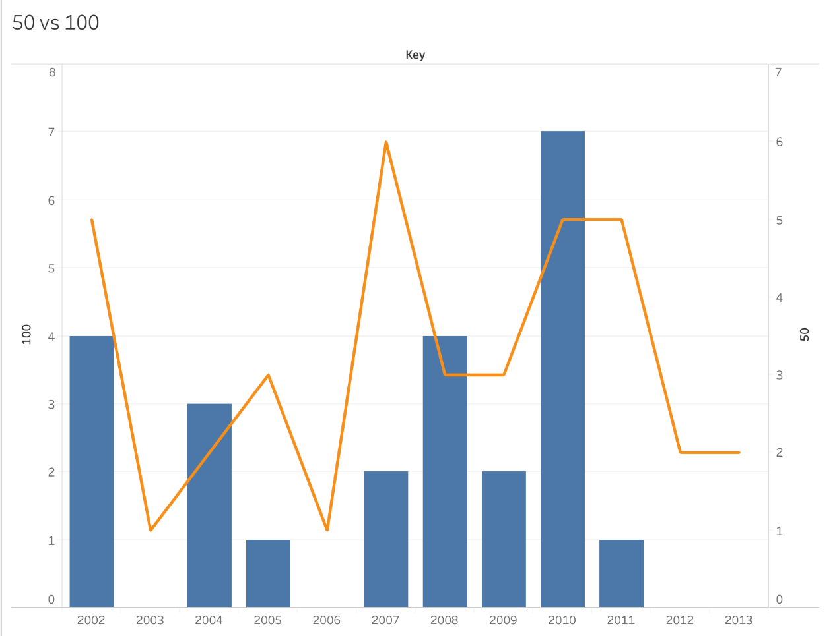

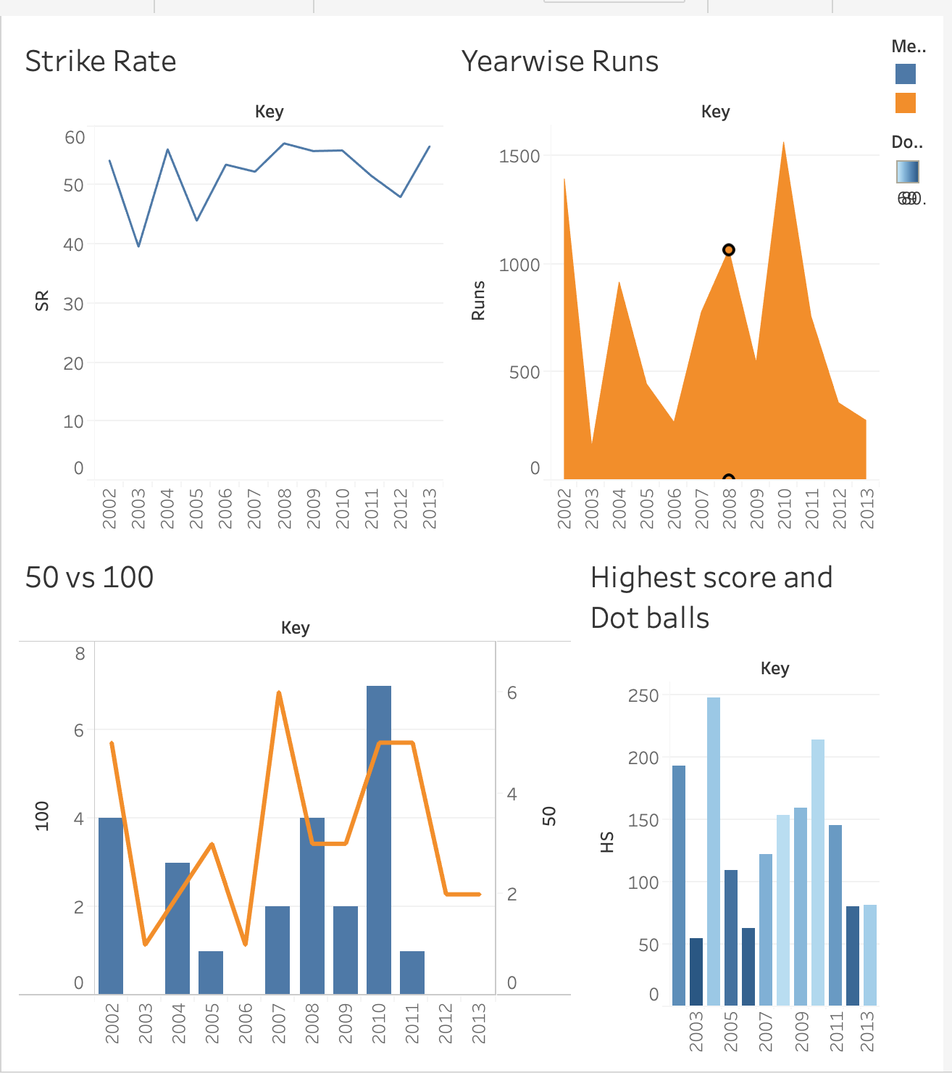

# Conclusion:

Created a dashboard which helps us to understand data in given dataset.

Also gives a clear view about specific details which we need.

Dashboard we’ve created, helps us to find out how many customers are there in a particular region and how much amount is spent on a particular category of transaction.